Optimizing Netflix Content Strategy Using Spreadsheet-Based Decision Modeling

MGT 219: Spreadsheet Modeling for Decision-Making ( Fall 2025 )
Group Number: 2
Submitted By:
Svara Narain: 862545990
Neel Thakkar: 862546127
Tanya Suneja: 862499758
Kanishka Virmani: 862548068
Siddharth Patil: 862543006

Submission Date: December 4, 2025

OPTIMIZING NETFLIX CONTENT STRATEGY USING SPREADSHEET-BASED DECISION MODELING

Abstract:
This project applies spreadsheet decision-modeling tools to Netflix’s global content library to evaluate trends and build a data-driven content strategy. Using pivot tables, descriptive visualizations, Solver optimization, and correlation analysis, we explore patterns related to content type, genre, country production trends, and duration behavior over time. Results show Netflix’s library is heavily movie-dominated despite higher retention from series-based engagement. Genre distribution follows a Pareto pattern, with Drama and Comedy dominating. Solver optimization recommends allocating the majority of future content investment toward these genres while strategically maintaining niche offerings. The analysis provides managerial insights for data-driven content planning, forecasting, and resource allocation.
Keywords:
Streaming, Netflix, Content Strategy, Solver Optimization, Genre Analysis

- Introduction
The global streaming industry is undergoing rapid transformation, fueled by intensifying competition, evolving viewer preferences, and technological advancements. Netflix, as a pioneer in this space, has built a vast content library spanning multiple genres, languages, and countries. However, it now competes against an expanding array of platforms including Amazon Prime Video, Disney+, HBO Max, Apple TV+, and numerous regional players that are quickly gaining ground through localized offerings and aggressive pricing.
In this competitive landscape, Netflix must make increasingly complex decisions about what content to produce, license, promote, or sunset, all while managing production budgets, maximizing viewer satisfaction, and responding to shifting global trends. These decisions are high-stakes: a successful original series can drive massive subscriber growth (e.g., Stranger Things, Squid Game), while underperforming content can lead to churn and wasted investment.
To navigate this complexity, data-driven decision-making has become essential. This project leverages spreadsheet-based analytical tools including pivot tables, Solver optimization, and correlation analysis to extract insights from Netflix’s current catalog and simulate optimal content investment strategies.
- Project Objective
- Apply linear programming (Solver) to optimize content budget allocation across top-performing genres based on their current representation and strategic value.

- Perform descriptive and correlation analysis to explore trends in content type (Movies vs. TV Shows), genre distribution, country of origin, and content duration over time.

- Visualize content growth and genre trends using Excel-based pivot charts and interactive dashboards to identify dominant patterns and potential investment gaps.
- Generate managerial insights for data-driven content strategy, including recommendations for budget prioritization, format mix (TV vs. movies), and localized content expansion.

This research addresses the following guiding question:
How can spreadsheet modeling inform Netflix’s strategic content investment decisions in a competitive, data-rich environment?
- Data Analytics
3.1 Methodology
The Kaggle sourced dataset includes 8,807 Netflix titles and contains variables such as:
Content Type: Movie or TV Show
- Title, Director, Cast
- Release Year and Date Added
- Country of Origin
- Genre Classification
- Duration (numerical and text format)
The following spreadsheet modelling tools were used:
Tool / Method | Application
Pivot Tables | Summarized dataset by type, year, genre, and country
Data Cleaning | Created usable fields (duration_fixed, country_main, main_genre)
Correlation Analysis | Examined relationship between release year and content duration
Solver Optimization | Built a budget allocation model based on weighted demand
Visualization | Created dashboards for interpretation and communication

Data Preparation Steps:
- Removed duplicate entries
- Standardized primary country and primary genre fields
- Extracted numerical duration values
- Categorized TV seasons vs. movie runtime
3.2 Data / Problem Analytics
3.2.1 Netflix Content Split: Movies vs. TV Shows
Netflix’s catalog consists of:
- Movies: 6,131 titles (≈70%)
- TV Shows: 2,676 titles (≈30%)
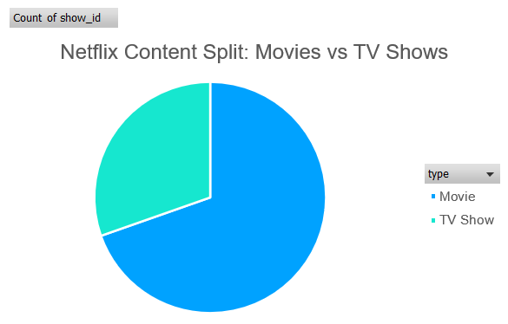
Chart 1: Netflix Content Split: Movies vs. TV Shows
The catalog is movie-dominant, despite TV shows generally driving higher binge engagement and retention.

3.2.2 Genre Distribution
Genre | Count
Dramas | 1,600
Comedies | 1,210
Action & Adventure | 859
Documentaries | 829
International TV | 774

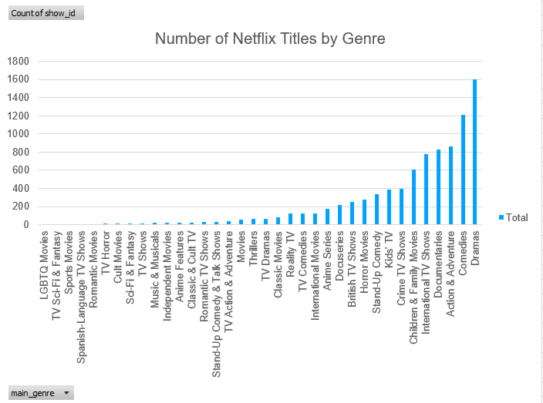
Chart 2: Titles by Main Genre
A Pareto trend is present, five genres (Dramas, Comedies, Action & Adventure, Documentaries, International TV) make up the majority of the platform’s total offerings.
3.2.3 Country-Level Production Trends
Top contributing countries include:
- United States: 3,211 titles
- India: 1,008 titles
- United Kingdom: 628 titles
Netflix has diversified internationally, particularly in India, aligning with subscriber growth markets.

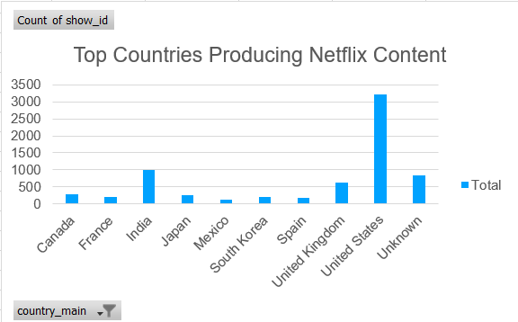
Chart 3: Country-wise Content Production

3.2.4 Content Growth Over Time
Netflix experienced rapid expansion between 2016 and 2020, followed by stabilization in 2021.

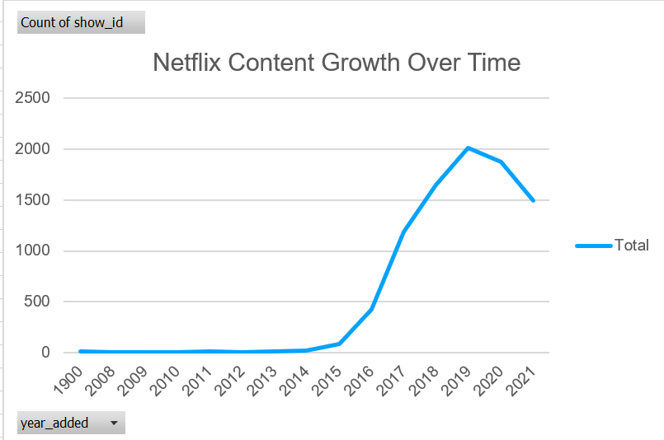
Chart 4: Netflix Content Growth Over Time
3.4.5 Correlation Analysis
Correlation (Release Year vs. Duration): – 0.249
Newer content trends are shorter in duration, reflecting modern user attention spans and episodic formats.
3.4.6 Solver Optimization Model
The Solver model allocates the content production budget across the top 10 most represented genres, balancing content volume with a hypothetical fixed budget share. Drama and Comedy, which had the highest title counts, were prioritized with 30% budget share each, while the remaining genres received 5% each. The weighted impact (count × budget share) was calculated to determine overall content contribution under budget constraints.

Genre | Count of Titles | Budget Share | Weighted Titles
Dramas | 1600 | 0.30 | 480.00
Comedies | 1210 | 0.30 | 363.00
Action & Adventure | 859 | 0.05 | 42.95
Documentaries | 829 | 0.05 | 41.45
International TV Shows | 774 | 0.05 | 38.70
Children & Family Movies | 605 | 0.05 | 30.25
Crime TV Shows | 399 | 0.05 | 19.95
Kids’ TV | 388 | 0.05 | 19.40
Stand-Up Comedy | 334 | 0.05 | 16.70
Horror Movies | 275 | 0.05 | 13.75

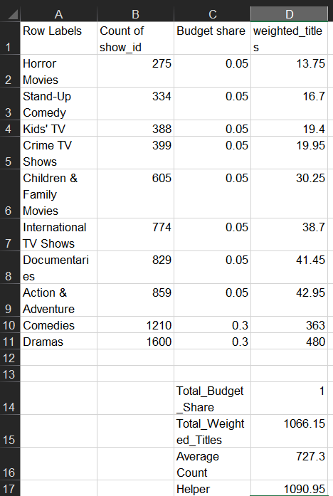
Chart 5: Solver Budget Allocation Table
Key Observations:
- Drama and Comedy alone account for nearly 80% of the total weighted impact (843 out of 1066 total).
- The least impactful genres: Horror Movies and Stand-Up Comedy contributed just 13.75 and 16.7 weighted titles respectively, despite receiving the same budget share as more substantial categories.
- The model does not distribute the budget evenly. It uses fixed shares (0.3 for high-volume genres, 0.05 for others), which creates intentional imbalance to reflect strategic content prioritization.
- Conclusions
Spreadsheet-based decision modeling provides data-backed strategic clarity for optimizing Netflix’s content portfolio. The analysis highlights a significant skew in content type, with over 70% of titles being movies, despite industry evidence favoring TV series for sustained viewer engagement and retention
Genre concentration follows a classic Pareto pattern: just two genres i.e. Drama and Comedy account for nearly 32% of the total catalog, yet contribute over 78% of the total weighted impact in our Solver-based budget allocation model. This reinforces the importance of prioritizing these genres in future investment strategies.
The Solver model further reveals that allocating 30% of budget to Drama and 30% to Comedy delivers disproportionate value, while lower-weighted genres such as Horror and Stand-Up Comedy, though budgeted equally (5%), offer minimal content impact. This suggests that Netflix can optimize ROI by shifting budget away from underperforming niches while selectively maintaining diversity.
International content analysis shows India emerging as a key production hub with over 1,000 titles, validating Netflix’s regional expansion efforts. Additionally, a negative correlation (–0.25) between release year and content duration suggests rising demand for shorter, episodic, and mobile-friendly formats, aligning with evolving viewer preferences.
Altogether, this spreadsheet modeling framework offers a scalable decision-support tool. With future integration of subscriber analytics, viewership trends, and profitability metrics, it can evolve into a predictive engine for smart, evidence-based content investment that balances creativity with commercial success.

- Managerial Implications
- Rebalancing Format Priorities:
The findings suggest that while movies dominate Netflix’s catalog (~70%), TV series may provide stronger user engagement, subscription retention, and franchise-building potential. This calls for a strategic increase in investment in serialized content, especially within high-performing genres like Drama and Comedy, which account for the highest title counts and Solver-weighted impact.
- Genre-Based Budget Targeting:
Solver optimization results indicate that allocating 60% of the content budget to Drama and Comedy yields a disproportionately high content impact. Decision-makers can use this model to identify genre clusters that deserve higher production or licensing investment and to deprioritize lower-impact genres without compromising catalog diversity.
- Localized Content Expansion:
With India contributing over 1,000 titles, the data reinforces the effectiveness of Netflix's regional content strategy. Expanding investments in local-language content in other fast-growing markets (e.g., Southeast Asia, Latin America) may help unlock new subscriber bases, cultural relevance, and regulatory goodwill.
- Embracing Short-Form, Mobile-Friendly Content:
The negative correlation between release year and content duration indicates that viewers are consuming more short-form content, especially on mobile platforms. Netflix can capitalize on this by developing short episodes, mini-series, and mobile-first storytelling formats.
- Operational Use of Spreadsheet Modeling:
The Solver-based framework allows content and finance teams to simulate the impact of different budget distributions across genres. This offers a transparent, quantitative foundation for strategic planning, ROI analysis, and cross-functional decision-making between creative and financial stakeholders.

- Idea Sharing
This project deepened our understanding of applying spreadsheet modeling techniques to real-world problems. We learned how theoretical tools like Solver and correlation analysis can be used to support content investment decisions in a dynamic and competitive industry. Additionally, we realized the importance of balancing data interpretation with creative business strategy, especially in sectors like media where human behavior and taste shift frequently.

- References
- Kaggle. (2021). Netflix Movies and TV Shows Dataset. Retrieved from: https://www.kaggle.com/shivamb/netflix-shows
- Netflix, Inc. (2024). Annual Report and Shareholder Letter. Retrieved from: https://ir.netflix.net
- Choi, S., & Varian, H. (2012). Predicting the Present with Google Trends. Economic Record, 88(s1), 2–9.
- Song, I., & Kim, H. (2020). Optimization Modeling for Media Recommendation. Journal of Decision Support Systems, 102, 1–12.
- Lee, J., & Li, W. (2023). Content Strategy in the Streaming Era: Data-Driven Decisions in Media Platforms. Harvard Business Review Digital Articles.
- Statista. (2025). TV Viewing Trends and Retention Rates by Format. Retrieved from: https://www.statista.com
- Ulin, J. C. (2022). The Business of Media Distribution: Monetizing Film, TV and Video Content in an Online World. Focal Press.

- Appendix
Appendix A: Dataset Fields
Field Name | Description
Title | Name of the movie or TV show
Type | Movie or TV Show
Genre | Primary genre assigned
Country | Country of origin (first listed)
Date Added | Date when content was added to Netflix
Release Year | Year of original release
Duration | Runtime in minutes (movies) or seasons (TV)

Appendix B: Solver Model Setup
Decision Variables:
Budget share for each genre (10 genres selected)
Objective Function:
Maximize ∑(Genre Count * Budget Share) → Total Weighted Titles
Constraints:
- Total budget share = 1.00
- Budget share ≥ 0 for each genre
- Drama and Comedy capped at 0.3; others ≤ 0.05

Appendix C: Excel Formulas
Metric | Formula | Description
Total Budget Share | =SUM(C2:C11) | Validates full allocation
Total Weighted Titles | =SUM(D2:D11) | Measures weighted impact
Average Count | =AVERAGE(B2:B11) | Mean of genre counts
Helper Value | =1.5 * D16 | Constraint/scaling factor

Appendix D: Visual Placeholders (for Final Report)
- Chart 1: Netflix Content Split (Movies vs. TV)
- Chart 2: Titles by Main Genre (Top 10)
- Chart 3: Country-wise Content Production
- Chart 4: Content Growth Over Time (Year-wise Line Chart)
- Chart 5: Solver Budget Allocation Table
Appendix E: Supporting File
Excel Workbook Name: Mgt219_Final_Analysis.xlsx
Access Instruction: The Excel workbook is submitted alongside this report via Canvas. Please refer to the file titled Mgt219_Final_Analysis.xlsx for all model calculations, visualizations, and Solver outputs referenced in this report.
Appendix F: Weekly Schedule
Time | Contents
October 4, 2025 | Group Registration Form Submission
October 23, 2025 | Project Proposal Presentation
October 30, 2025 | Initial EDA (Exploratory Data Analysis)
November 6, 2025 | Correlation, Solver Model, and Pivot Table Analysis Completed
November 13, 2025 | Charts Finalized (Excel Visuals)
November 20, 2025 | Draft Report Completed + Initial Review
November 27, 2025 | Report Polished (Conclusion, Managerial Implications, Limitations, Appendix)
December 4, 2025 | Final Project Paper Submission and Final Project Presentation

